because I said I would.

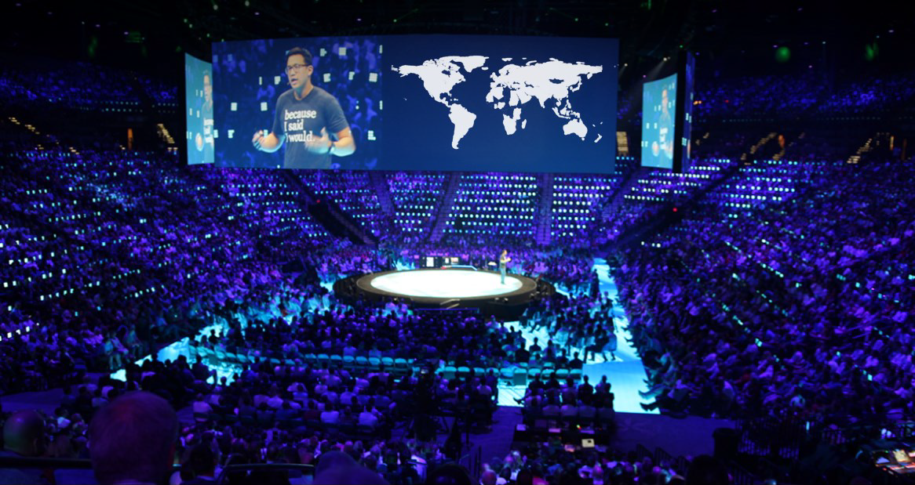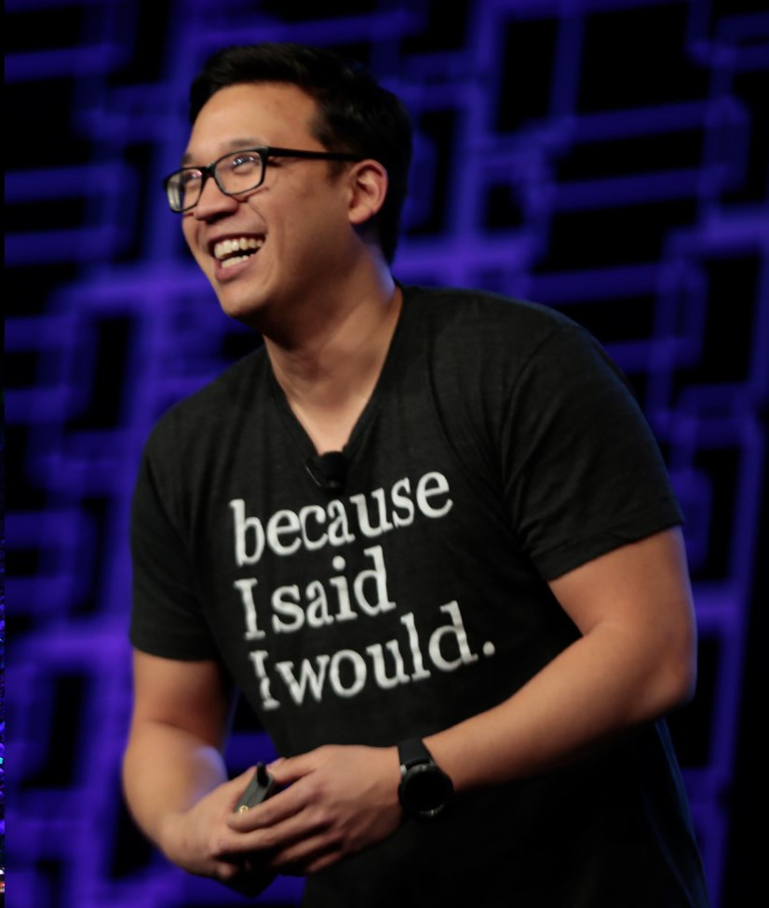

Founder, because I said I would.

Sparked by the loss of his father, Alex began sending Promise Cards to anyone who requested them **at no cost**. Since his father’s

passing on September 4, 2012, *because I said I would* has sent over

***15.1 million* Promises Cards** to **over 178 countries.**

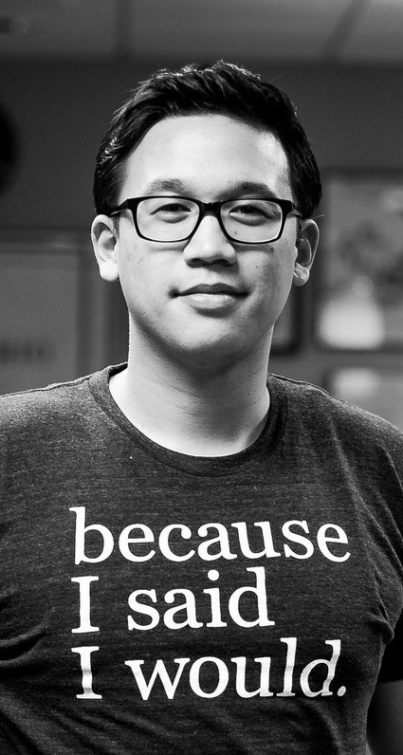**Alex is one of the foremost experts**

on **promises** and commitment.

Alex is a **five-time ** **speaker**, author, podcast host and internationally-recognized humanitarian. As one of the world’s foremost experts on accountability and

commitment, Alex is an author, podcast host, and Founder of the because I said I

would movement. His work has been featured on the TODAY Show, Good Morning America, the Steve Harvey Show, CNN, Fox News and many other programs.

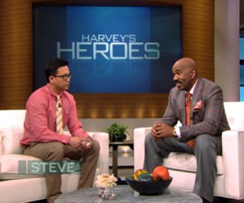

**Look familiar?**

You may have seen Alex in one of his many media appearances.

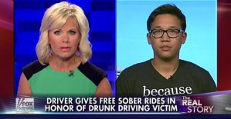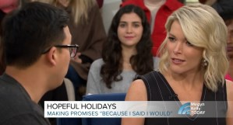





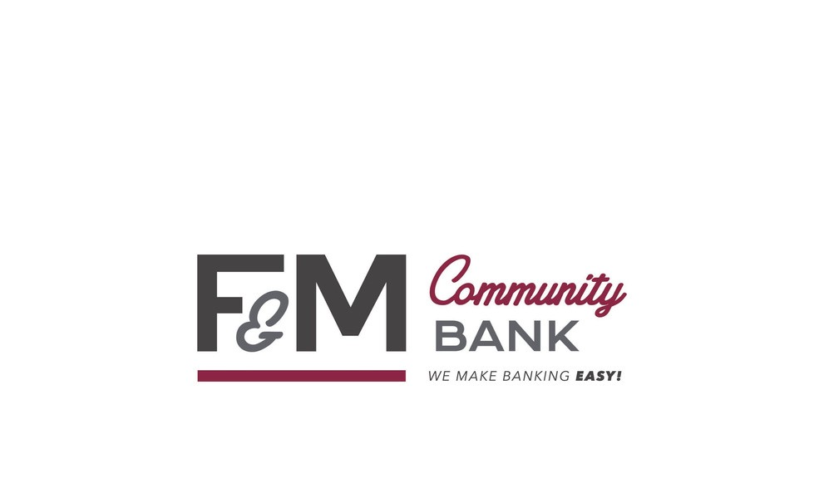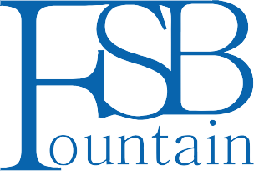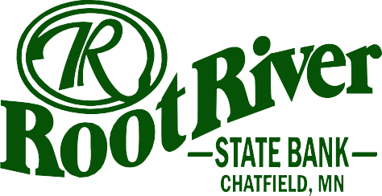

**Alex Sheen, Inspirational Speaker on Accountability and Commitment**

**Wednesday, December 6th**

**7:00pm | Chatfield Center for the Arts | Community Event**

**Admission is free, but advanced reservations are appreciated. Reserve your seats today at** [**chatfieldarts.org**](https://link.edgepilot.com/s/c198772d/if2Kqjdp20qc_oo8RsSy_w?u=https://app.arts-people.com/index.php?show=210840)

**Tickets are FREE thanks to the generosity of the sponsors:**